Procedure to Enter/Search/Modify Non-Custody ADULT Arrests in Spillman
THE ARREST
- To access the arrest/custody screens for entering or searching:
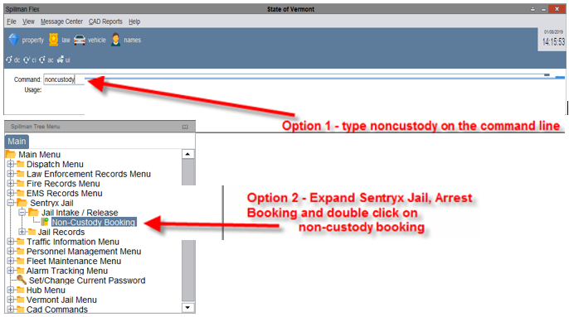
Adding a Non-custody Arrest “Booking” Record
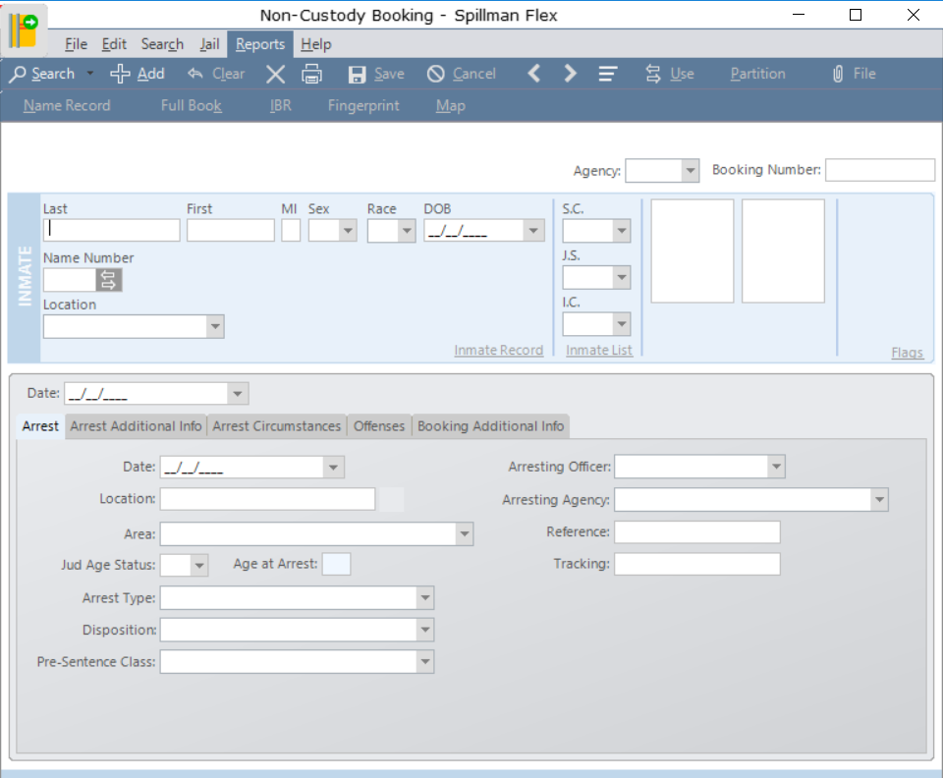
- This window will now open, Click Add:

Click on add to start booking
- This will take you to the Inmate Search Screen.
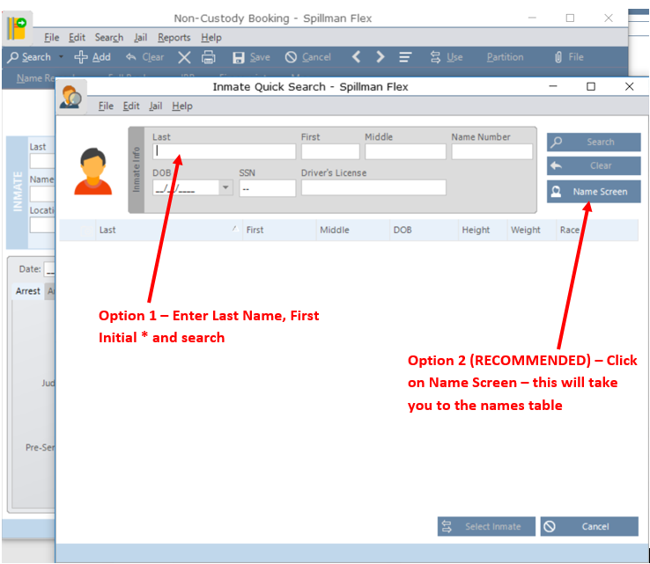

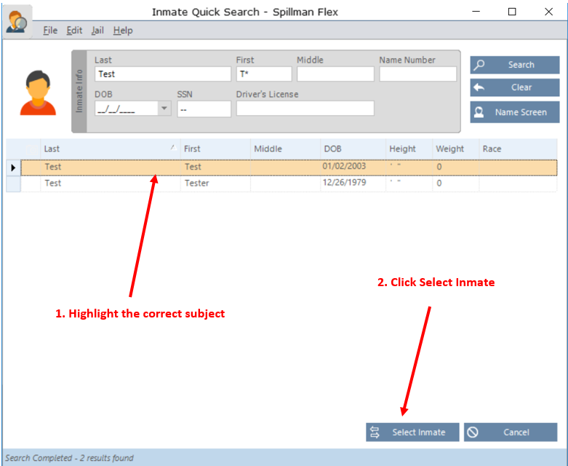
- Option 1 for finding the subject: Enter Last Name, First Initial * and enter – results returned look like this:

- From Option 2 (RECOMMENDED) – you will see the following:
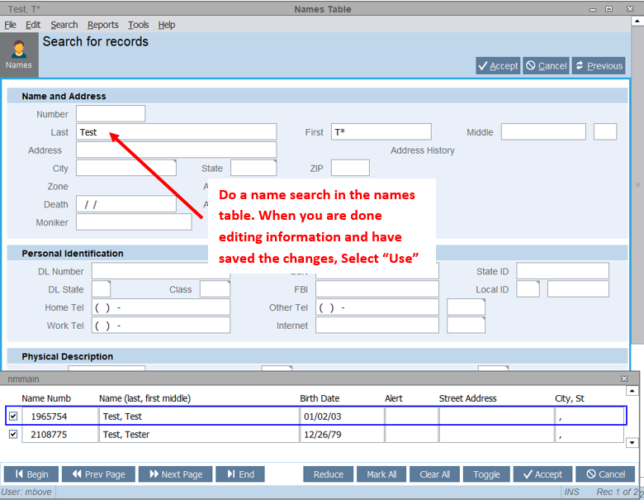
- Once you have done the search in the names table and made any modifications and select “USE” you are here: 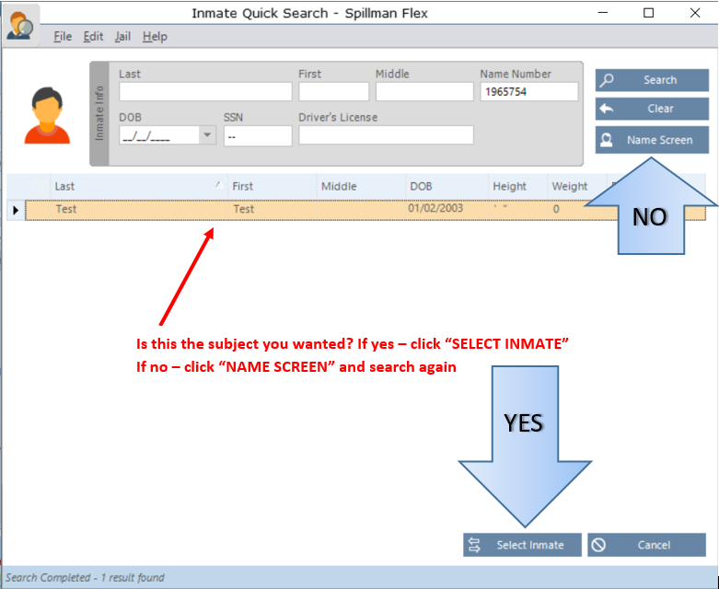

- Once you have clicked on “SELECT INMATE” (using either of the search options) you are here:
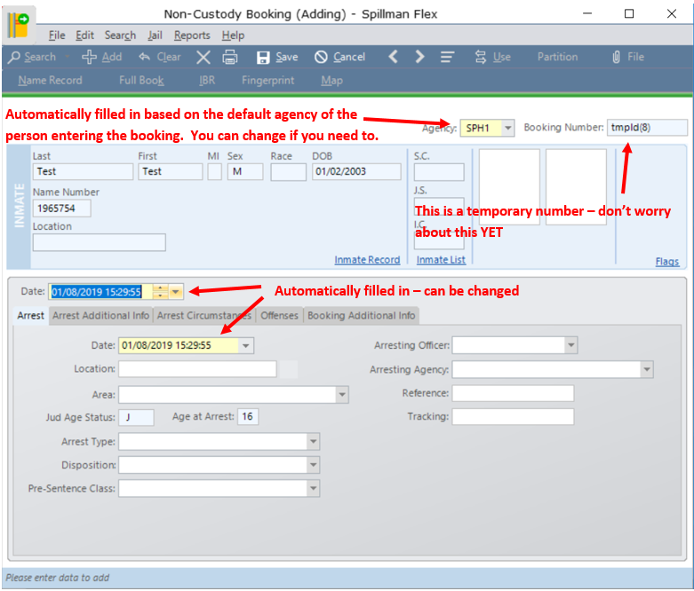
- The Agency field is automatically filled in based on the default agency of the person entering the booking. You can change this if you need to. (For example if you are a State Police Dispatcher and enter an arrest for another agency – you will want to change this to the proper agency.)
- At this point the booking number is a temporary number. You don’t need to remember or write this number down yet. Once you hit save (explained in the next slide) you will have your booking number.
- Both Date fields are filled in automatically; you will change either of these fields as necessary.
  - The Top Date field is the date of the entry into Spillman.
  - The Date field below the tabs is the date and time of the arrest.
- Location: This is the location of the arrest. For example: 103 South Main Street
- Area: This is a drop-down field.
- Judicial age: This is automatically filled in by the system based on the date of birth of the subject.
- Arrest Type: A drop down menu.
- Disposition: This is for Juveniles. LEAVE BLANK IF THE ARRESTEE IS 18 OR OLDER.
- Pre-sentence class: A drop down menu that you most likely don’t need for arrests.
- Arresting Officer: Start typing the last name of the officer and select the correct one when it comes up on the screen.
- Arresting Agency: Drop down menu – select the arresting agency
- Reference and Tracking: this is used by some departments for internal tracking. This is not the incident number!

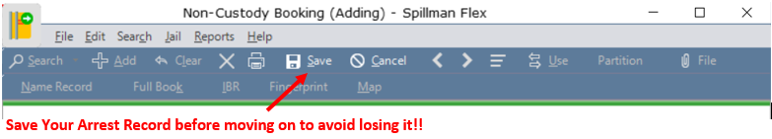
- Now select Save from your toolbar. This is when the booking number is created.
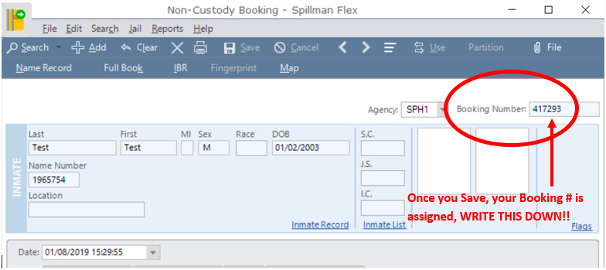
Did you write down the Booking #? If not, do so now!
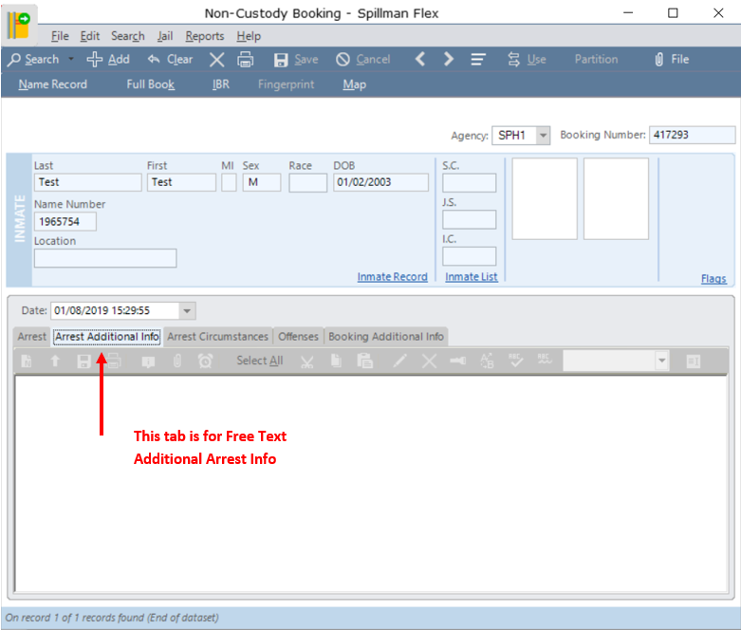
- If your agency attaches additional comments to an arrest, you would Select the Additional Info tab and enter it there.

- Now Select the Arrest Circumstances tab. This is where you list all items an arrestee was armed with, if the individual was unarmed or additional circumstances. Click the asterisk and select from the drop down menu options. Select Save on the toolbar to save all your entries.
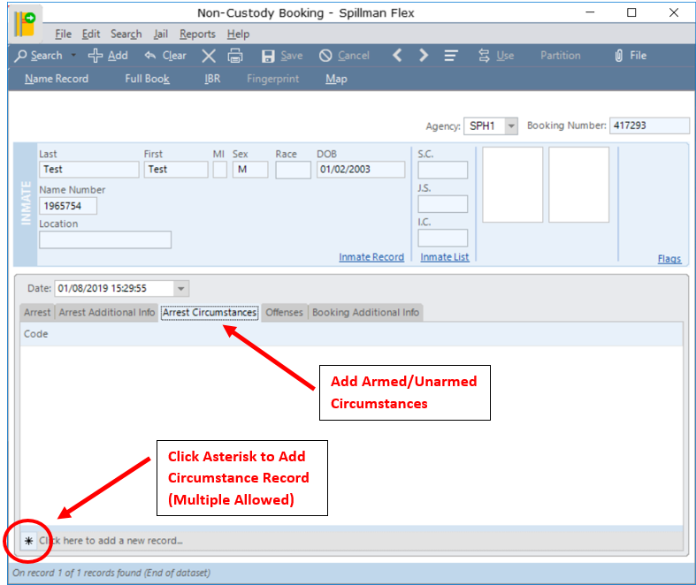

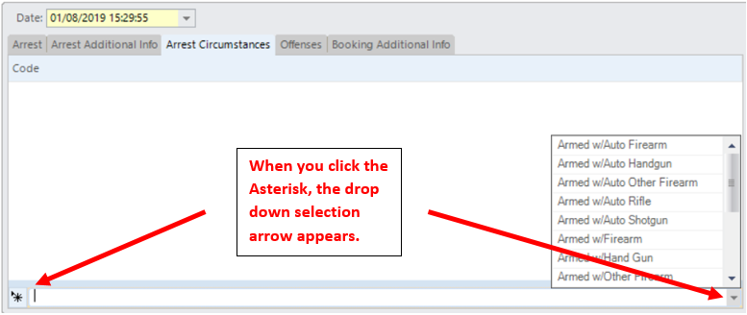

- Now the Offenses. Click on the “Offenses” tab in the middle of the screen – (You have the booking # written down, right?!). You are now on this screen:
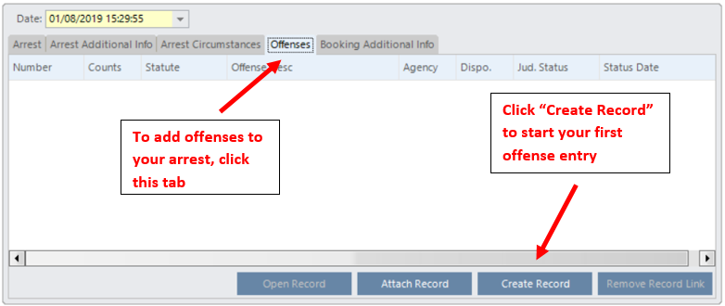

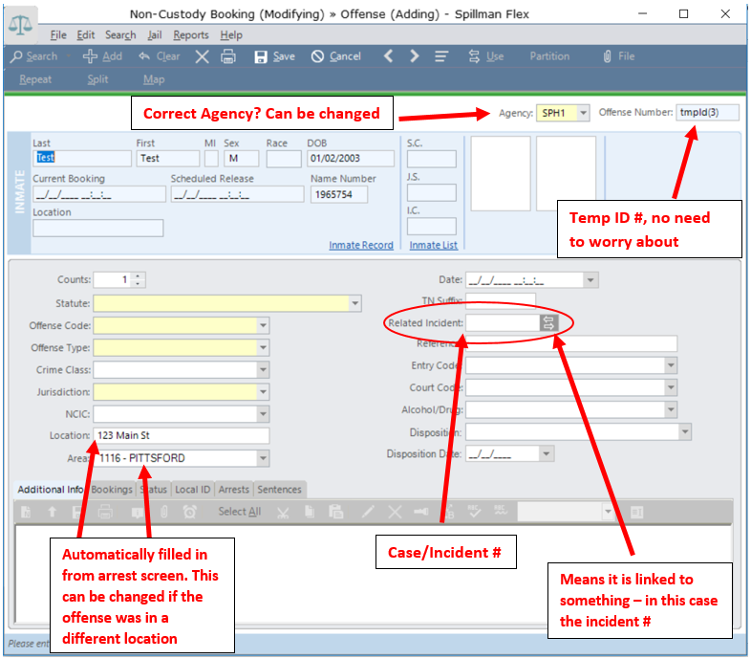
- Complete all information
- Statute: this is a drop down menu, located correct statute, several other fields many automatically be populated.
- Date: date and time of offense if known.
- TN Suffix, NCIC – not used at this time
- Reference: is used by some departments – complete if needed. (This is NOT the incident number!)
- Related Incident: This is the incident number related to this charge or count!
- Entry code, Court and Alcohol/Drug: are all drop down menus.

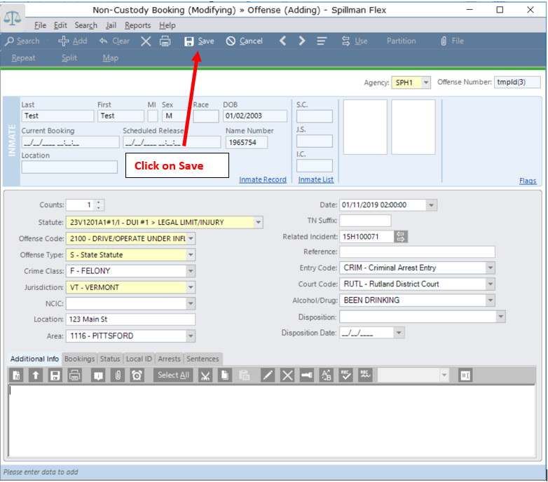
- Once all this is complete CLICK ON SAVE in your toolbar to avoid losing your data!

- You will now see the option for USE. This means “Use this offense in my arrest record”. Click on it.
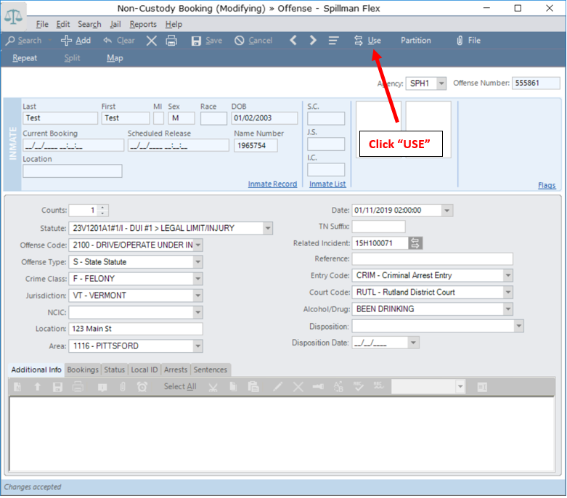
- You are now here:
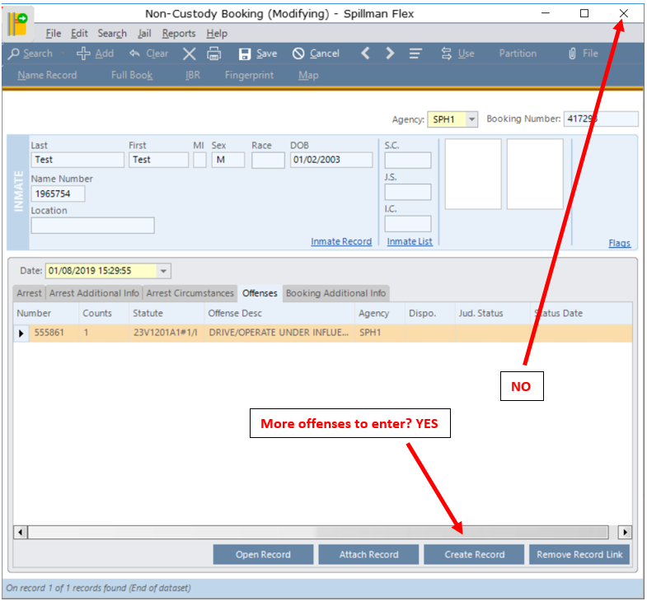
- If you have more offenses to enter – CLICK on “Create Record”. Continue until you are done. Notice on the offense screen you also have a “Count” option, which allows you to enter multiple counts of the same record easily.
- Once you are done entering all offenses. – CLICK SAVE! And then CLICK on the “X” upper right corner to close the close your noncustody arrest record.

TO PRINT THE ARREST/CUSTODY REPORT
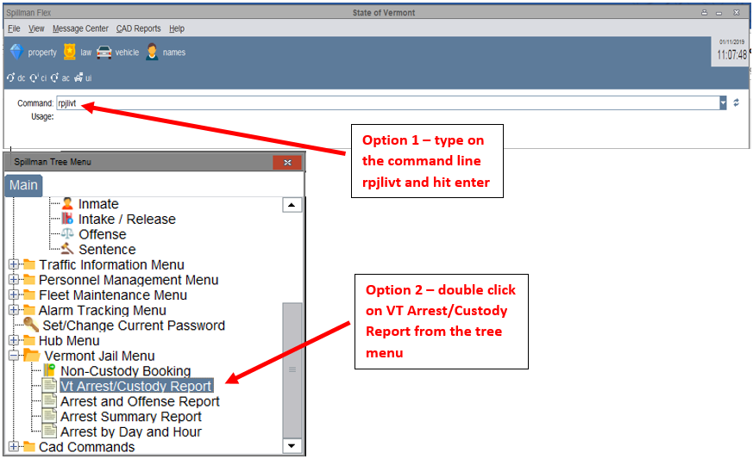
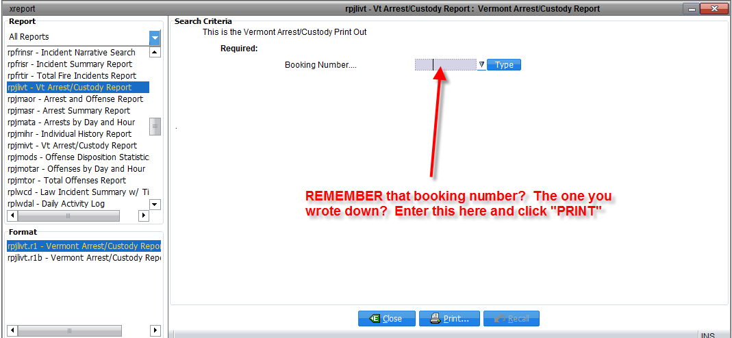
- This takes you here:

- Oops… I forgot the booking number!! The dog ate the piece of paper I wrote it on!! No problem. Go back to the command line and type noncustody, or use the tree menu and select Non-Custody Booking.
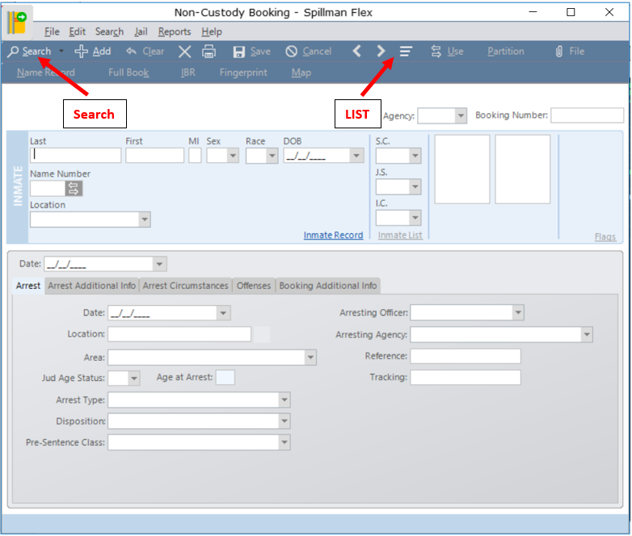
- Search for the name, and hit list. Find the booking number from the list and go back to the rpjlivt report to print.

TO MODIFY EXISTING NONCUSTODY ARREST RECORDS.
