HOW TO PROPERLY FILL OUT/APPROVE A REPORT
The purpose of this guide is to help officers and supervisors know what must be included in a Spillman Law Incident and what is intended to go into each field. When filling out a report, it is important to make sure any information that is approved is accurate since this becomes the long-term record of the incident as well as the basis from which most statistical information is derived. In many instances, information is reported to the FBI under the National Incident Based Reporting standard and is checked and audited by both the State NIBRS Program and the FBI for accuracy and completeness.

In most cases, the officer enters the report. Whether an officer, a dispatcher or a records person does the data entry is not important. The final authority for the case still rests with the approving officer, usually the officer's immediate supervisor. Once a case is written and approved, it is assumed complete and accurate.

What follows is a brief explanation of each field in the law incident and what should be entered. Each numbered field is based on the number of the field obtained when using the `spacebar' option when Search is highlighted at the top of the Law Incident.
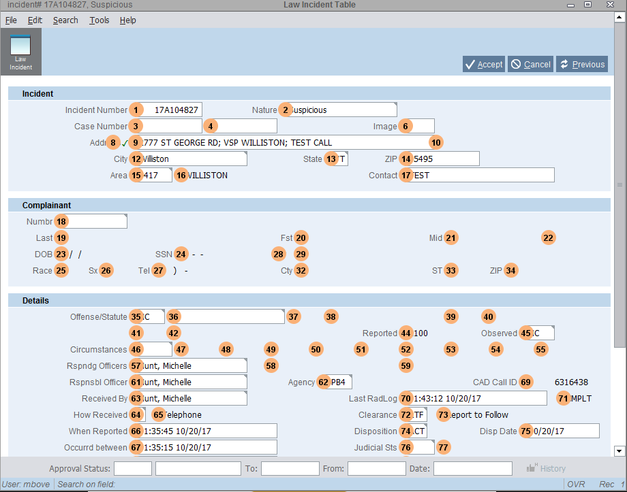

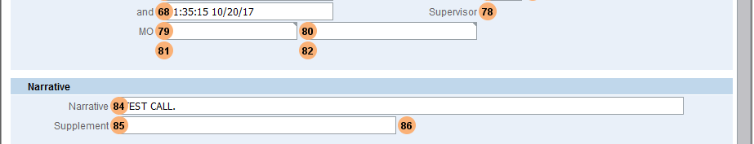

- Incident Number - the case number. This cannot be changed.

2. Nature - This is entered by dispatch and is the best guess of the dispatcher when the call is received. You should not normally change it. However, if for some extraordinary reason it must be changed (and it should not be changed normally) use a Nature from the Lookup Table.

3-4. Case Number – These fields are not currently used.

6. Image – This field is not currently used.

8-14. Address and City of the Incident - Where the Incident happened.

15-16. Area – Important! The town code where the incident happened. This is how we know in which 'real town' the incident occurred in. This is important for Vermont State reporting, so please make sure it is filled in.

17. Contact - Someone to see or talk to about the complaint. This could be someone different than the Complainant. (Usually filled in by Dispatch.)

18-34. Complainant Information - This is the complainant's name information. Check to see that the information is as accurate and complete as possible. This usually comes filled in from dispatch, but the officer may find out more at the complaint and need to add/modify it. (To view the complainant's name record, go to involvements or tap Lookup(F2) while the cursor is in the complainant ID Number field).

Please note - There are times when the Complainant should be left blank. For example, when the officer is reporting the crime, as in a DWI resulting from a traffic stop. Or when the complainant is a business. In this instance, the Complainant field should be left blank. You would put the officer’s name or caller’s name in the contact field, and any Victims would be listed as an Involvement.

35-42. The Offense Codes are the officer's classification of the crime. These are based on a national standard defined by the FBI, not Vermont statutes. The most common mistake made is to report 'lesser included' offenses here.

For example, if a house is broken into, property stolen and a door damaged, there should only be one offense code. Do not report a burglary, a vandalism, a larceny and a trespass in this example. They are all elements of the Burglary. If there is more than one offense, for example, sexual assault and burglary, these would both be reported. See the FBI's NIBRS Manual for further explanation.

44. Reported - This is the computer's best 'guess' as to what the offense might be based on the Nature. It cannot be changed.

45. Observed - This normally comes from dispatch when the Trooper clears the scene and goes 10-24. He/she can give the dispatcher an observed code (like the old 'verified' code) over the air. This will be the most serious of the Offenses reported.

46-55. Circumstances - There are five types of circumstances that are required when the Law Incident is a Group A crime to report to NIBRS. The State of Vermont collects domestic violence and civil marijuana ticket Circumstance codes also. This is an easily searchable field and codes can be added (by Betty Wheeler) for your agency for tracking certain calls.

1. Bias (or Hate) Crime
Bias must be reported. If the facts are ambiguous, report Bias as Unknown BM99. If there is no sign of bias, use BM88. Use of any of the others is only when investigation reveals sufficient objective facts to lead a reasonable and prudent person to conclude that the offender's actions were motivated, in whole or in part, by bias against a racial, religious, ethnic/national origin, or sexual orientation group.

2. Location Type
All crimes must have a location code.

3. Suspected of Using
Offender Suspect of Using - If you suspect that the offender used alcohol or drugs before or during a crime, or used a computer to commit the crime, include the appropriate code.

4. Type of Criminal Activity
Necessary for the following offenses:
- Counterfeiting/Forgery
- Stolen Property Offenses
- Drug/Narcotic Violations
- Gambling Equipment Violations
- Pornography/Obscene Material
- Weapons Law Violations

5. Weapon/Force Used
Report the most specific weapon or force used for the following offenses:
- Murder and Manslaughter
- Homicide
- Kidnapping
- Forcible Rape
- Forcible Sodomy
- Sexual Assault with an Object
- Forcible Fondling
- Robbery
- Aggravated and Simple Assault
- Extortion/Blackmail
- Weapons Law Violation In other words, every assault type of offense requires some type of weapon/force used. Do not use any 'weapon/force used' for other offenses, such as Burglary.

Domestic Violence (DOMV) and Civil Marijuana/Hashish ticket (DPCM/DPCH)
Use these codes whenever domestic violence or a civil ticket for marijuana/hashish is a factor in the offense.

57-59. Responding Officers - The officers who went to the complaint. You can add or subtract if necessary.

61. Responsible Officer – Is the one to write the primary report for this incident.

62. Agency - The agency code to which the report belongs. This is what the computer uses to give or deny access to other agency's reports. You will not be able to change this.

63. Received by – The name of the person who added the call (usually a dispatcher). This is not usually changed.

64-65. How Received - By telephone or in person, etc. This is not usually changed.

66. When Reported - When the Law Incident was entered. This is not usually changed.

67-68. Occurred Between/And - If the dispatcher knows this and fills it in (in CAD) it will show here. If the officer wants to or needs to - change it.

69. Call ID - This is the long-term Call ID that generated this Law Incident. It will be in involvements and includes all the information the dispatcher took on the call.

70-71. Last Radiolog - The last radio log entry attached to the case. This is not usually changed.

72-73. Clearance - These are meant to be used internally for the office or departments' control of cases. Use the five R's:
- Report to Follow (RTF)
- Ready for Approval (RFA)
- Returned to Responsible Officer (RTO)
- Reviewed by Sergeant (RBS)
- Reviewed by Lieutenant (RBL)
The usual procedure would be as follows:
The dispatcher clears the call with the clearance of RTF. The Trooper writes the case and changes the code to RFA. The supervisor finds cases that are marked RFA and approves them, changing the code to RBS.

74. Disposition - The official case status according to the FBI standards.

-If it is a crime, it is active or cleared by some kind of arrest or exceptional circumstances.
-If the law incident is not a crime, i.e., lost person, accidental fire, traffic accident, you may use the code COM (complete).

It is very important that you do not use the code COM for any reportable Group A crimes. If you have a crime and you do not know who did it, the crime remains ACT (active). If you have a crime and you made an arrest then the code would be cleared by CAA (Arrest). Exceptional clearances are used when you know who did it, but for some reason do not/cannot arrest. If you Clear a case by arrest or use Exceptional clearance, you must name the offender in the involvements.

75. Disposition Date - This normally defaults to the date the call came in. The date can be changed when an arrest is made. The date is the date the disposition changed from the old (i.e. ACT) to the new (i.e. CAA).

76-77. Judicial Status - This field is not currently used. Do not fill it in.

78. Supervisor - This field is has the approver’s name. Do not abbreviate, put in call signs or login names. Enter a name and title so if someone later wants to know who approved this case, anyone can tell by looking at it. For example "Sgt. Waller" or Lt. O'Leary"

79-82. MO (Modus Operandi) - Not required, but if it might be useful in future investigations, it should be filled in.

84. Narrative - The investigation narrative. All associated narratives (or supplements) should be saved here for long-term retrieval. A narrative must be present for all reportable crimes for validation purposes.

85-86. Supplements - One or more supplements, by the responsible officers and/or assisting officers.

NOW GO TO INVOLVEMENTS- Victims, offenders, property and vehicles must be entered here. Also anyone else associated to the case (i.e witnesses, operators, etc).

