Valcour Gov Board
5/10/23

Attendees: Vegar Boe, Michael Manley, Eric Shepard, Michelle Hunt, Steve Laroche, Betty Wheeler, Matthew Sullivan, Craig Gardner, Justin Stedman, Benjamin Webster, Mark Anderson, Adam Cohen

Call to Order
10:07

Agenda
Mark – Any objections to Agenda being sent out 6 days prior instead of 7? No objections.
Also, need to add Elections/Access Policy and need to add an executive session today. No objections.

Approve Minutes
Vegar Motion, Manley seconded
Passed unanimously

VGB Makeup/Charter Vote
Mark – changed notice of agenda to 3 days instead of 7 for regular meetings and emergency meetings to as soon as reasonably possible.
Article II – took the initial language and put that into place, went from 11 to 13 members, added 2/3 vote requirement to elect, identified the nominated parties and who they represent and proposed Term Lengths for each. Kept the language specific to elections and removal of members.
Justin – identified a couple of typos
Michael – asked about the Terms/Mark advised will discuss Terms separately
Michael – also asked to have language added that the member is removed from the Board if no longer employed by the sponsoring agency.
Mark – updated the language
Mark - July 1st, 2023 is the start for all
Justin - said to remove the Terms for now. Historically it hasn’t been an issue. It usually works itself out.
Vegar - advised there is more issues trying to find reps than keeping them
Mike - also agreed that the Terms should be removed
Mark – deleted the Terms
Justin – motion to adopt/Vegar seconded. Then discussion about the 2/3 vote resulted in it must be 2/3 of the serving members and there must be a quorum (Roberts Rules still apply). Also, discussed missing 3 consecutive meetings automatically removes the member based on the current Charter.
Passed unanimously

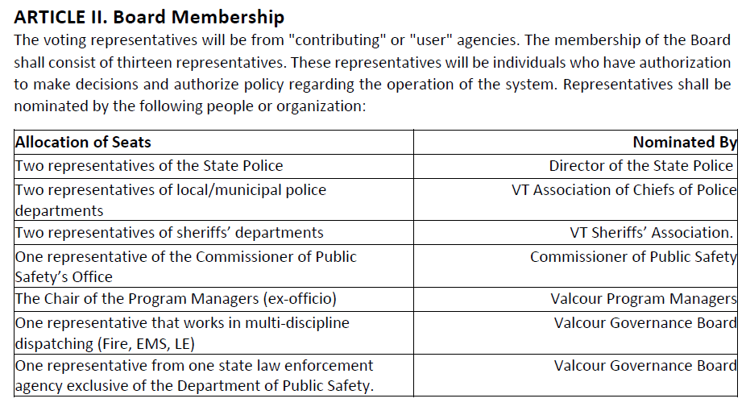
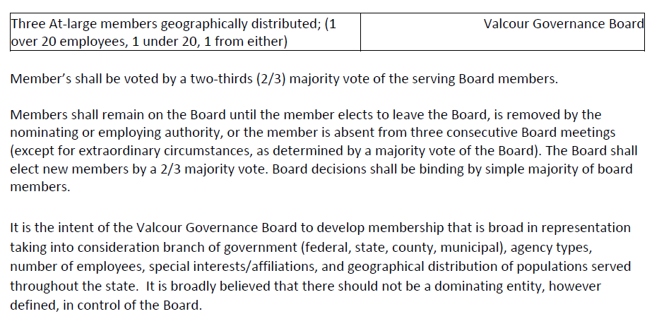

Nominations
Mark - Need to take up nominations:
Sheriffs Association - Mark Anderson and Dan Gamelin
VSP – Michael Manley and Betty Wheeler
Commissioner of Public Safety’s Office - Sean Loan
VT Association of Chiefs of Police - Loretta Stahlmaker and Matt Sullivan
Justin - Moved to accept above nominations/2nd by Vegar
All in Favor – Passed Unanimously
PM Chair - Jen Beane
Mike - nominated Michelle Hunt/Justin seconded
Betty - nominated Justin Stedman for non-DPS
3 At-Large geographically distributed - under 20 Eric Shepard nominated by Steve - either is Vegar - over 20 is Adam (all 3 accepted)
Steve - is departing
Motion to elect – Steve motion, Justin seconded
Mark – forgot Jen Beane, Michelle Hunt and Justin Stedman
Vegar - motion to approve all nominations, Betty seconded
All in Favor – Passed Unanimously

VGB Chair, Vice Chair and Secretary
Mark - Chair serves a 1yr term and is limited to 3 consecutive terms. This upcoming year will be my 3rd.
Vegar - motion to approve Mark for one more term, Justin seconded
All in Favor – Passed Unanimously
Vegar - who is Marks proxy if he’s unavailable.
Mark - Eric is the Vice Chair. Should we wait to approve Vice Chair and Secretary at July's meeting?
Vegar - motion that Eric Shepard will become the next Chair at the end of Marks term. Eric accepted.
All in favor - unanimous
Eric - nominated Jen to continue being secretary
All in favor – Passed Unanimously

Executive Session
Mark - Looking for a motion to enter executive session to discuss potential policy violation
Vegar motion, Eric seconded - moved to Breakout room @ 10:48
Return to public room - no action taken @ 11:13

Access Policy
Mark - what circumstance would the Board revoke or suspend access, what does the process look like, UA says VGB can do that - this is more about establishing that process. Policy now or committee for later?
Mike - suggested piggy backing off of VCIC
Steve - brought up #9 of the UA
Michelle - copying the current UA to add to the Governance Board Website
Mark proposed:
-It is the policy of the Valcour Governance Board that upon notification by VCIC of a user's revocation or suspension of access to restricted data shall
constitute grounds for suspension of access to Valcour in accordance with IX. Sanctions of the Valcour User Agreement.
-Agency heads are responsible to disable a user's account and to notify the Valcour Governance Board in the event that a user within their agency has had access to
restricted data suspended by VCIC
-Agency heads who have their access to restricted data suspended by VCIC shall notify the Valcour Governance Board who will cause the account to be suspended
in Valcour.
Action Item - Michelle will put it into policy template
Mark - suggested committee be put together to expand on the what the procedure will be
Vegar - motions to have Mark make the policy as read aloud, Betty seconded
Adam - motion to approve the new policy, Steve seconded
All in favor – Passed Unanimously
Mark - Any volunteers for the committee? Adam, Vegar & Betty volunteered

Adjournment
Eric - Motion to thank Chief Laroche and Sgt Gardner for their time with the Valcour Board, Seconded by Mark
Motion to adjourn by Justin, Steve seconded
Passed unanimously 11:45

