Vermont Orders and Warrants System

The Vermont Orders and Warrants System (VOWS) is an electronic database to track Warrants and Protection Orders through their lifecycle. This replaces the need to keep paper copies at any physical location.

Logging into the VOWS Platform
To log into the VOWS platform, navigate to https://vjiss2.dps.state.vt.us/vermont-vows-portal/ .
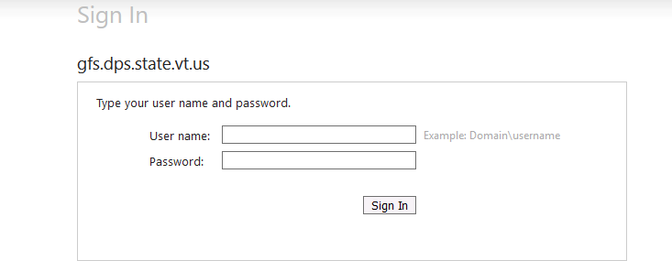

Enter your Username and Password. To set up a username and password, a ticket will need to be filed with the DPS Help Desk. To do that, please follow this link:
https://itsupport.apps.vermont.gov/

If you already have a DPS username, but have forgotten your password, please call the DPS Help Desk at (802) 241-5525.

The Dashboard
The Dashboard is the first screen after logging into the platform. This Dashboard is tailored to the user’s organization. Users will see a different series of items displayed for their attention depending on the status of the document.
Issuing Agencies are agencies which issue Court Orders or Warrants. Issuing Agencies are not always courts, though. The Department of Corrections’ Parole and Probation Board is also an Issuing Agency.
Record Holding Agencies are those which hold records, either their own records, or because of an agreement which is in place for them to hold records for another agency.
Servicing Agencies are those which service, or serve, warrants and court orders. These include Law Enforcement Agencies which execute warrants and issue court orders in their everyday processes.

An example of the Dashboard is included below, the view has been compacted:
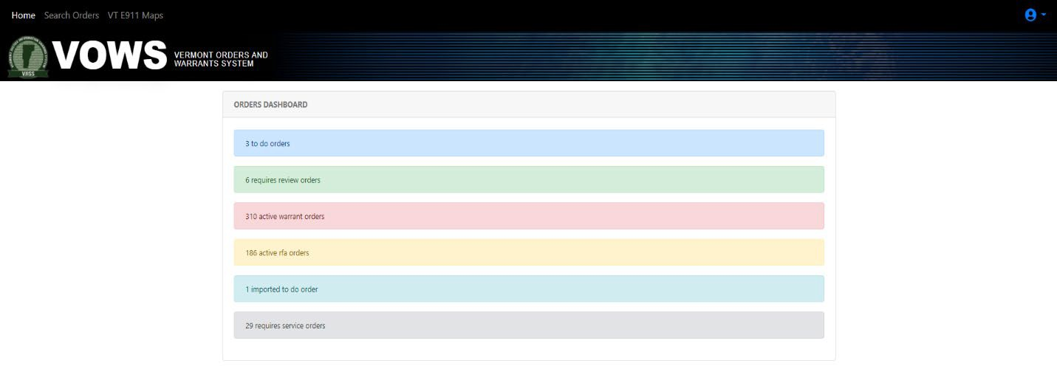
Orders are organized on this page based on the documents to which your Agency has a claim.
To Do Orders and Requires Review Orders are those which are awaiting action by your Agency. Something needs to be done to move these orders to the next stage of their lifecycles.
Active Warrant Orders are those which are active in the system and waiting for service. For example, when someone is pulled over and it is determined that they are someone who needs to be served, the order will appear in this section of the dashboard. There are more orders in the VOWS platform than what you see on the dashboard, though, as the records displayed on the dashboard are those to which your Agency has a claim.
Active RFA Orders are those which show served or served pending review.
Imported To Do Order is used for uploading entries for Agencies as they migrate to VOWS. In this case these orders need to be audited by the Originating Agency/Record Holding Agency and moved to their correct status.
Requires Service Orders are Protection Orders that have been issued and need to be served.

Links Along the Top
Along the top of the web page, there are a couple of quick links to other places. These navigation items are present on every page of the VOWS platform.
Home will return the user to the Dashboard page.
Search Orders will bring the user to the Search page.
Enter New Order will be visible if the user is in an agency which issues warrants and court orders and will bring the user to a page to enter a new warrant or order.

VT E911 Maps navigates to the online E911 map for the public. You can view the first responders for any address by turning on the ESZ under Quick E911 Tools > Change Visible Map Layers > E911 Base Layers > then check box next to ESZ (LAW, FIRE, EMS) to see the responders
https://maps.vermont.gov/e911/Html5Viewer/?viewer=e911responder

Disclaimer: The Vermont Enhanced 911 Viewer map and GIS data is for general reference only. Data layers that appear on the Enhanced 911 Viewer map may or may not be accurate, current, or otherwise reliable.

There is also a small icon in the upper right corner which is specific to the user. If clicked, it shows who the user is currently logged in as, and has an option to Sign Out of the system:
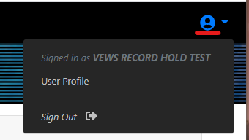
There is also an icon for the user’s profile, which shows the Agencies to which the user has claims. These claims are governed by NCIC and the user’s corresponding account in the message switch through their OpenFox account. The Sign Out option is also located here. It is always a good idea to Sign Out of a web service when finished. Login credentials are often saved in the user’s web browser, which can lead to a security breach.
Searching in the VOWS Platform
Clicking on the Search Orders link in the header of the VOWS platform will bring up the Search interface:
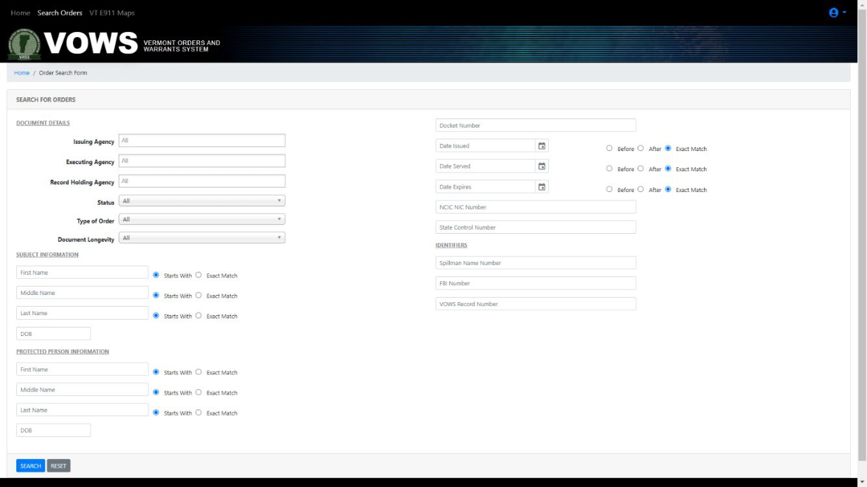

There are a lot of options here because there are a lot of ways to search for something. To search for a specific user or record, as few or as many search parameters can be entered as necessary. The more search criteria filled in, the more specific the returned results will be; the fewer, the more general. Simply clicking on the Search button in the lower left will bring up all entries currently in the system. Searches will include individuals outside of an Agency’s claims, allowing users to search the entirety of the orders and warrants present in the VOWS platform.
A simple search without entering any parameters will give a result like the following:
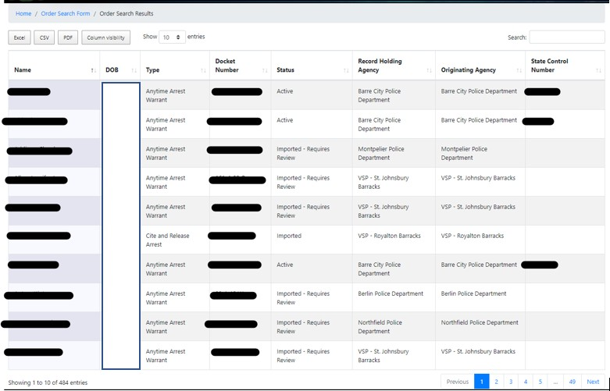

Specific names, docket numbers, and State Control Numbers are redacted in this example, since this is a screenshot from the live data. Different views can be displayed of the search set by clicking the Column Visibility button. Here, one can choose which columns to hide, so that the search is relative to what the user is searching.
The text box in the upper right corner labeled ‘Search’ allows for the user to select other criteria upon which to filter the results. For instance, entering ‘Simpson’ in that text box would remove someone named ‘Smalls, Pamela’ if her entry was displayed. Search criteria entered in the text box can be used for any of the columns displayed – DOB, Type of Order, or other fields like the Status or Record Holding Agency name.
The Excel, CSV, and PDF buttons allow for the current search set to be saved to an Excel, CSV, or PDF file. In this way, records could be audited and compared to other lists, or simply a record of the items in the search set can be saved digitally.

Record Status
The Status field of the record contains several possible status entries for Warrants and Protection Orders:

Warrants

Imported – A temporary status to show that a mass number of records were injected into the system. These records are set to Imported – Requires Review once they have been audited by the Courts.
Imported – Requires Review – This record has been reviewed by the Court and is ready for the Record Holding Agency to enter/modify the State Warrant Database (SWD) or NCIC. After it has been entered/modified, it is moved to Active Pending Review.
New – Recently entered record from the Issuing Agency which requires attention (entry into SWD and NCIC if applicable). This will show up in the To Do folder for the Record Holding Agency.

Active Pending Review – A warrant which has been entered into SWD/NCIC but needs to be checked by a second person to make sure all policy and steps were appropriately followed. After the second check is performed, it is moved to Active

Active – An active warrant, ready to be served as necessary.

Removed Pending Review – The warrant has been removed from SWD/NCIC but needs to be checked by a second person to make sure that all policy and steps were appropriately followed. After the second check is performed, it is moved to the associated Pending Disposition choice.

Pending Disposition – Served, Pending Disposition – Unknown, Pending Disposition – Withdrawn, Pending Disposition - Cited – The Record Holding Agency moves the warrant to the Pending Disposition choice that reflects the reason for removal out of SWD/NCIC. This will notify the issuing agency that the record is ready to be disposed.

Disposed – The Issuing Agency selects this status once the warrant has passed through their policies and procedures for it to be disposed.

Withdrawn – Arrested, Withdrawn – Dismissed, Withdrawn – Vol Appearance – The Issuing Agency has decided to Withdraw the warrant, because of error or because the subject has reported to the court. This status will notify the responsible Record Holding Agency to remove the subject’s entries from SWD/NCIC. Once the warrant has been removed, the Record Holding Agency changes the status to Removed Pending Review.

Workflow and Status Progression of
Anytime Arrest Warrants/DOC ROMs/DOC Commissioner’s Warrants
A description of the available statuses and the expected workflow associated with where that warrant entry currently resides in VOWS is detailed in the table below.

Status | Issuing Agency | Servicing Agency | Record Holder
Imported:  Denotes an entry introduced to the system by IT staff. | A To-Do item which needs to be verified. Once verified set to Imported – Requires  Review | N/A | N/A
Imported – Requires Review:  An entry which needs to be verified for accuracy and NCIC/SWD entry. | N/A | N/A | A To-Do item which needs to be verified. Once verified set to Active Pending Review
New:  An entry recently created by an Issuing Agency. | All new entries are set to New when they are entered. Selecting the Record Holder, adding documentation, and then saving will send a notification to the  RH. | N/A | A To-Do item which needs extra data about subject entered, including NCIC/SWD entries as necessary. Once entered set to Active Pending Review
Active Pending Review: NCIC-required step to double check entry. | N/A | N/A | A Review item for the agency. NCIC-required step to be sure all information is accurate. Once verified set to Active
Active:  An item which is active and awaiting service when the subject is located. | N/A | An item for law enforcement to serve when the subject is located. Notification and service documents are sent to the Record Holder for entry. | Once law enforcement has served the Active item and sent service documentation to the Record Holder, the entry is updated with service documentation and the date of service. NCIC/SWD entries are cleared in OpenFox. Entry is then set to Removed Pending Review
Removed Pending Review:  NCIC-required step to double check removal. | N/A | N/A | A Review item for the agency. NCIC-required step to ensure NCIC/SWD has been cleared. Once verified, set to the associated Pending Disposition choice.

Status | Issuing Agency | Servicing Agency | Record Holder
Pending Disposition: Notification sent to the Issuing Agency that the warrant has been served. | To-Do step for the Issuing Agency to verify that all necessary paperwork has been completed on the item. Once satisfied, set to  Disposed | N/A | N/A
Disposed:  Final status of a warrant which has passed through the workflow. | Final status of the warrant. Subject to the Issuing Agency’s data retention  policies. | N/A | N/A
Withdrawn:  An item which is being removed for any reason, such as it was served at a courthouse or was entered in error by an  issuing agency. | Set by the Issuing Agency. | N/A | Creates a To-Do for the Record Holder. NCIC/SWD entries are cleared from OpenFox. Once this has been done, set to Removed Pending Review

Protection Orders

Imported – A temporary status to show that a mass number of records were injected into the system. These records are set to Imported – Requires Review once they have been audited by the Courts.
Imported – Requires Review – This record has been reviewed by the Court and is ready for the Record Holding Agency to enter/modify NCIC. After it has been entered/modified, it is moved to Active Pending Review.
New – Recently entered record from the Issuing Agency which requires attention (entry into NCIC). This will show up in the To Do folder for the Record Holding Agency. Once the order is entered, the Record Holding Agency will change the status to Issued Pending Review or Served Pending Review.
Issued Pending Review – An order which has been entered into SWD/NCIC but needs to be checked by a second person to make sure all policy and steps were appropriately followed. After the second check is performed, it is moved to Issued.
Issued – Order has been entered in NCIC and is ready to serve. Note: Until all agencies are on VOWS, the Record Holding Agency will continue to fax or scan the documents to the appropriate Agency for service.

Issued – Dormant > 12 months – An order which has been entered into SWD/NCIC and has not been served or has an unknown service status for over a year. This status should only be changed by the court or Agency TACs based on their audits.

Requires Service – A document uploaded by the issuing agency that needs to be served (ex: Hearing Notice).

Served Pending Review – An order which has been entered into NCIC but needs to be checked by a second person to make sure all policy and steps were appropriately followed. After the second check is performed, it is moved to Active
Served – Order has been served and is active.
Vacated – The Issuing Agency has decided to Vacate the order. This status will notify the responsible Record Holding Agency to clear the subject’s entries from NCIC. Once the order has been cleared, the Record Holding Agency changes the status to Removed Pending Review.
Replaced – By Extension, Replaced – By Final – The Issuing Agency has replaced the temporary order with an extended temporary or final order.
No Final – The Issuing Agency has decided there is No Final order. This will move the order into the To Do folder of the Record Holding Agency.
Removed Pending Review – The order has been cleared from NCIC but needs to be checked by a second person to make sure that all policy and steps were appropriately followed. After the second check is performed, it is moved to Pending Disposition.
Pending Disposition, Pending Disposition - Expired – After the second check, the Record Holding Agency moves the order to the appropriate Pending Disposition option to notify the courts that the record is ready to be disposed.
Disposed – The Issuing Agency selects this status once the order has passed through their policies and procedures for it to be disposed.

Procedures for the Workflow

Warrants

Newly issued warrants will show up in the To Do Orders folder for the Record Holding Agency
- Run a SNQ on the defendant to make sure the name/dob are correct and to see if there is an existing record in the state database
- Make appropriate state database entries and updates
- Add the State Control number to the VOWS record, and enter any relevant service notes
- Change the status of the record from New to Active - Pending review.
- Save the record in VOWS, it should now appear in the Requires Review folder.
- Ask someone to double check it, the same as any other entry.
- Once the entry is double checked, the status should be changed to Active.

When a Warrant is Served
- The serving agency will provide a return of service (faxed or emailed typically)
- Scan or save the return of service so that there is an electronic copy ready to upload
- Find the relevant VOWS record (should be in the Active Warrants Folder)
- Make the necessary SWD/NCIC updates
- Upload the saved Return of Service to the “Service Confirmation” field in VOWS
- Change the VOWS entry to Removed - Pending review & add any relevant service notes. Save the record. It should now appear in the Requires Review folder.
- Ask someone to double check it. Once the entry is double checked, the status should be changed to Pending Disposition.
- Issuing agency then marks it Disposed

When a Warrant is Withdrawn
- The issuing agency will update the record status to Withdrawn. The record will then show in the
To Do Orders Folder
- Find the relevant VOWS record (should be in the Active Warrants Folder)
- Make the necessary SWD/NCIC updates
- Change the VOWS entry to Removed - Pending review & add any relevant service notes. Save the record. It should now appear in the Requires Review folder.
- Ask someone to double check it. Once the entry is double checked, the status should be changed to Pending Disposition.
- Issuing agency then marks it Disposed

Protection Orders

Newly issued restraining orders will show up in the To-Do Orders folder
- Run a SNQ on the parties to make sure the name/dob are correct and to see if there is an existing record in NCIC.
- Make appropriate NCIC entries and updates.
- Add the NIC number to the VOWS record and enter any relevant service notes.
- Change the status of the record from New to either Issued – Pending Review.
- Save the record in VOWS, it should now appear in the Requires Review folder.
- Ask someone to double check it, the same as any other entry.
- Once the entry is double checked, the status should be changed to either served or issued.
- If the order has not been served, create an appropriate Spillman case and/or send the order to the appropriate agency for service.

When an RFA is served
- The serving agency will provide a return of service (faxed or emailed typically).
- Scan or save the return of service so that there is an electronic copy ready to upload.
- Find the relevant VOWS record (should be in the ‘to be served folder).
- Make the necessary NCIC updates.
- Upload the saved Return of Service to the “Service Confirmation” field in VOWS
- Change the VOWS entry to Served – requires review & add any relevant service notes. Save the record. It should now appear in the ‘requires review’ folder.
- Ask someone to double check it. Once the entry is double checked, the status should be changed to served.

When a Final RFA is Issued
- A final RFA is entered into VOWS as a new record.
- Run a SNQ on the person to find the existing temporary RFA NCIC entry
- Make the necessary modifications to the entry (final, expiration date, etc…)
- Make the necessary modification to the VOWS entry. Change the status to either Issued – Pending Review or Served – Pending review.
- Save the record in VOWS, it should now appear in the “requires review” folder.
- Ask someone to double check it, the same as any other entry.
- Once the entry is double checked, the status should be changed to either served or issued.
- Search VOWS for the previous (temporary) RFA record
- Change the status of the temporary RFA record to ‘Pending Disposition’. Add a comment in the service notes indicating a final order was issued and save the record.

When an RFA is vacated / withdrawn
- The courts will change the status of the record in VOWS to Vacated. This will move it back into the To-Do folder.
- Clear the record in NCIC
- Add any relevant service notes in VOWS and change the status to “Removed – requires review”. This will move it into the Requires review folder.
- Have someone confirm it is no longer active in NCIC and change the status to “Pending Disposition”

When a Final RFA isn’t granted
- The court will change the status of the record in VOWS for the temporary order to “No Final” and add the expiration date. This will move it back into the To-Do folder.
- Clear the record in NCIC
- Add any relevant service notes in VOWS and change the status to “Removed – requires review”. This will move it into the Requires review folder.
- Have someone confirm it is no longer active in NCIC and change the status to “Pending Disposition”

HOW TO AUDIT YOUR WARRANTS

It is recommended that your agency audits their records at least once per month. Use the following steps:

Step 1 – Run a report in VOWS

- Click on Search Orders in the upper left-hand corner
- Enter your agency in the Record Holding Agency field
- Change the Status field to Not Disposed
- Click Search in the lower left-hand corner
- Use the Column Visibility button if you want to add/remove any of the columns and then export the information using the Excel, CSV or PDF button.

Step 2 – Run a report in OpenFox

- Query your agency’s ORI using these instructions:

Either Type “QSW” in the command line and press Enter – or – Select the “Query State Warrant File Form” from the Folder Structure, as seen below.
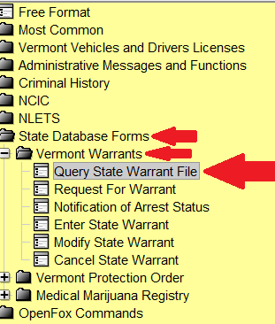
The QSW (QUERY VERMONT STATE WARRANT FILE) Form appears.

The ability to search for VT State Warrants depends on the Message Key (MKE) selected, as seen below.

Once the MKE and desired tab are selected, type in the search criteria (i.e. - ORI or AGENCY NAME) and click Submit or press Enter.

Depending on the MKE selected, the fields in the corresponding tabs will activate, as seen below. Fields for the unselected MKE will be inactive.

The QSWB by ORI option includes an alphabetical agency listing drop- down box & search functionality.

MKE = QSWB HOTFILES QUERY WANTED COURT-BASED - Allows searches based on Town, County, or ORI.

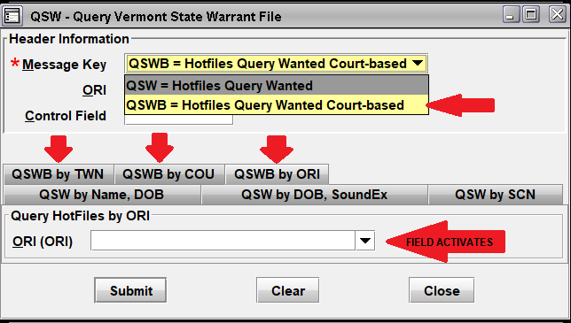

Step 3 - Compare your results. If there is a record active in VOWS and not in the state database or vice versa, contact the court for verification using the Court Contacts link at the top of VOWS.

